**Ecology:** The study of how all living & non-living parts of an environment interact

**Ecosystems:** A community of living organisms together with their physical environment

* Ecosystems may be large (oceans, rainforests) or small (tidal pools, a single tree)
* Parts of an ecosystem can be broken down into 2 types
  + **Biotic factors** living things and their interactions   
     (plants, animals, bacteria, disease, predation,competition, symbiosis)
  + **Abiotic factors** non-living factors (light, temperature, wind, oxygen, water & soil)

**Sustainability:** The ability to continue or maintain under pressure

**Sustainable ecosystem**: An ecosystem that can withstand pressure & support organisms

* Biotic & abiotic factors can influence the sustainability of an ecosystem

*Think- Pair- Share Activity*  
 Choose an ecosystem, identify 1 biotic and 1 abiotic factor in that ecosystem and   
 determine how they could influence the sustainability of the ecosystem

Ecosystem:____________

|  |  |
| --- | --- |
| Biotic Factor: | Abiotic Factor: |
|  |  |

For more examples of how biotic & abiotic factors influence sustainability see p. 286-287 of text

**Biomes:** Large natural regions with similar climate and plant life (ex. Rainforest, desert)

* Desert biomes in North America are very similar to those in Africa
* This is because similar combinations of abiotic factors (temperature, soil type etc.) determine what types of plant life will be present…. This then determines the types & abundance of other organisms etc.

Abiotic factors influence the distribution of organisms, abiotic factors influence biotic factors

**Populations & Sustainability**

**Population**: a reproducing group of organisms of 1 species living in an area

* Populations may increase, decrease or remain constant

**Equilibrium:** A state of balance with no net change over time

* A population in equilibrium is a population that is staying more or less the same
* Individuals die & are born at an equal rate

**Limiting Factors:** factors that limit the growth or distribution of a population (food availability,   
 disease, habitat quality)

* Limiting factors can help to keep a population at equilibrium
* Ex. If the population gets too high, they will start to run out of food or space & the population will decrease again

Limiting factors can be density dependant or density independent

**Density- independent factors:** the impact does not depend on the size of the population

* These are usually abiotic factors
* Ex. floods, fire, cold, pollution

**Density-dependant factors:** the impact depends on the size of the population

* These are typically biotic factors
* Ex. disease- the more dense the population is, the quicker disease will spread and will limit the growth of the population
* Other ex. Predation, competition

**Ecological Niche:** A species “place” or “role” in an ecosystem

* Includes the habitat it occupies, resources it uses, the abiotic factors that it can survive within, & its biotic interactions
* Ex. Pitcher plants grow in wet boggy areas & consume insects 

Complete **Investigation 7-2D** Predator-prey Simulation on p. 302 of text

**Carrying Capacity:** The size of a population that can be supported indefinitely by the resources   
 in a given ecosystem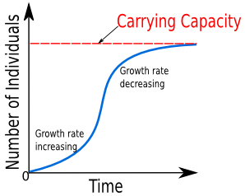

* An ecosystem with a high carrying capacity has enough resources to support a large population
* When a population is below its carrying capacity it will typically increase
* When it is at its carrying capacity it is in equilibrium
* If a resource is used at a rate that exceeds the carrying capacity, the population will reduce in size until it is balanced with the resources

When the fur seal hunt ended in 1911, the population grew quickly, then “leveled out” as it reached its carrying capacity

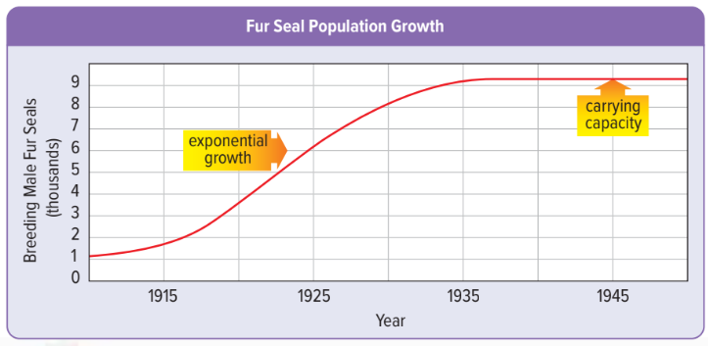

***Portfolio 1:***

1. As of 1945, how many fur seals could the ecosystem support?

2. What are two factors that might limit the fur seal population?

3. Is the factor you chose above density dependant or density independent? Explain

4. What is an example of something that might cause the carrying capacity to decrease?

5. Can a population rise above the carrying capacity? Explain

**Nutrient Cycles & Sustainability**

**Nutrients:** Substances that living things need to carry out their life processes

* Nutrients can be stored in organisms, oceans, land and the atmosphere
* Nutrients also flow through these different biotic and abiotic components

**Carbon & Oxygen Cycle**

* We will consider carbon & oxygen as combined cycles

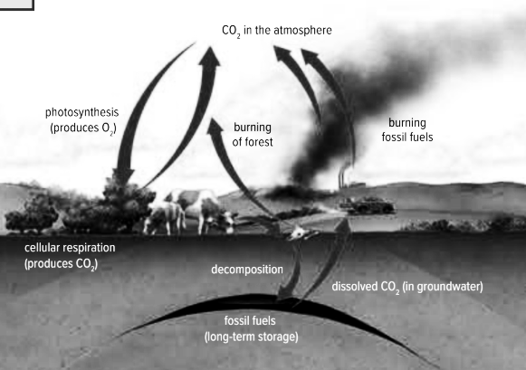

Two main processes contribute to carbon cycling: **Photosynthesis & Cellular respiration**

**Photosynthesis:** Chemical reaction used by plants and some other organisms to produce food

* Carbon dioxide, water & sunlight are taken in
* Sugar and oxygen are produced

6CO2 + 6H2O + light energy → C6H12O6 + O2



**Cellular Respiration:** Chemical reaction in the cells of most organisms

* Uses stored energy (sugar) and oxygen
* Carbon dioxide, water, & usable energy are produced

6C6H12O6 + 6O2 → 6CO2 + 6H2O + usable energy



Carbon is also stored in the ground through decomposition & released to the air through buring

**Nitrogen Cycle**

* 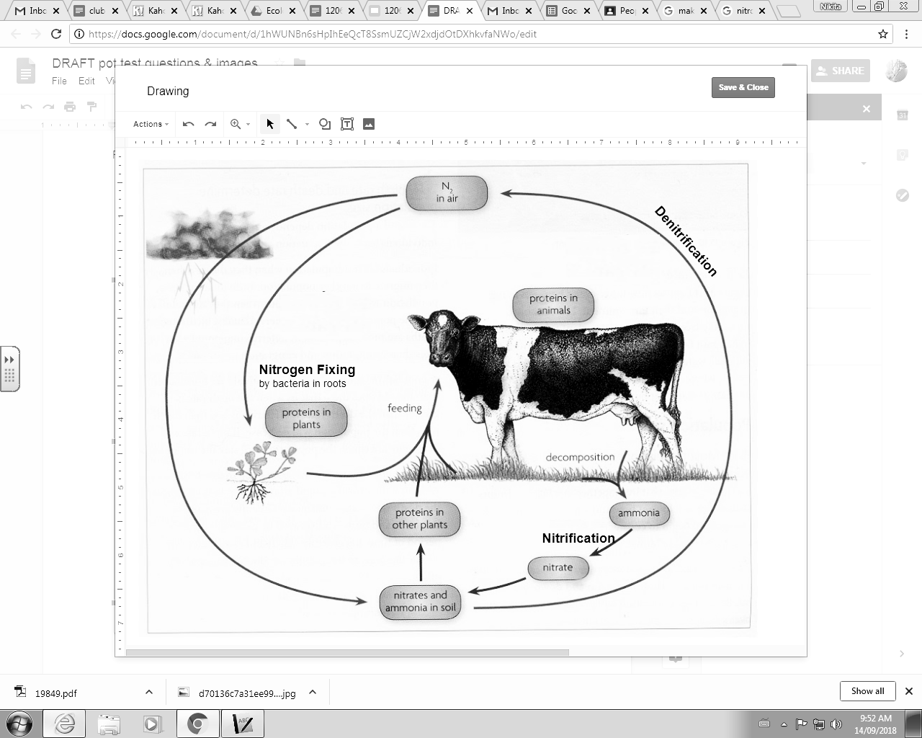~78% of air is nitrogen, but most living things can not use it directly
* Plants need to take up nitrogen in the form of compounds such as nitrate (NO3)



* Nitrate is formed 2 ways (lightning, nitrogen fixing bacteria in soil or plant roots)



**Nitrogen fixing** - Bacteria take nitrogen gas from the air and create nitrates for plants to use

**Nitrification**- During decomposition, ammonia is released



Bacteria convert ammonia to nitrite and then to nitrates  
**Denitrification**- Soil bacteria convert nitrates to nitrogen gas & release back to the atmosphere



**Nutrient cycles in aquatic systems**

* Fertilizers contain a lot of nitrogen
* When it enters water bodies it causes algae to grow rapidly (called a bloom)



**Eutrophication**- a buildup of nutrients in an aquatic system that leads to increased algae



* Occurs naturally but at a much slower rate
* Pollution causes the rate of eutrophication to increase







***Portfolio 2***



1.Why is it important that nutrients flow in a cycle?

2. How do photosynthesis & cellular respiration affect the carbon & oxygen cycle?

3. If a forest is clear cut, how might this affect the carbon & oxygen cycle?

4. What roles do bacteria play in the nitrogen cycle?

5. How does your lifestyle influence the carbon cycle?

**Soil Composition & Sustainability**

Soil can have a significant impact on the sustainability of an ecosystem

* Important in nutrient cycling
* Provides habitat for plants, bacteria and other organisms
* Filters water
* Regulates run off

Soils can be altered in many ways which can affect the ecosystem

* Adding manure adds organic matter to the soil which provides nutrients to plants
* Irrigating (controlled application of water) keeps moisture levels consistent & dissolves nutrients
* Fertilizers add nutrients which supports plants
* Adding substances such as lime can alter the pH to levels that are within a plants niche

Human activities can also lead to issues that reduce soil sustainability

* Removing vegetation increases erosion
* Use of machinery & vehicles increases soil compaction
* Adding fertilizers/ nutrients can cause eutrophication in aquatic systems and threaten the community



**Soil & Sustainability Lab Investigation**

**Energy in Ecosystems**

* The source of all energy in ecosystems is the SUN!
* This energy is used by green plants to make sugar (photosynthesis) which serves as food for all other organisms.
* This energy is transferred through food chains/ webs

**Trophic levels**: categories of organisms defined by how they gain energy

* Means “feeding level”

**Producers**

* make sugar from sunlight and carbon dioxide through photosynthesis.
* 1st Trophic Level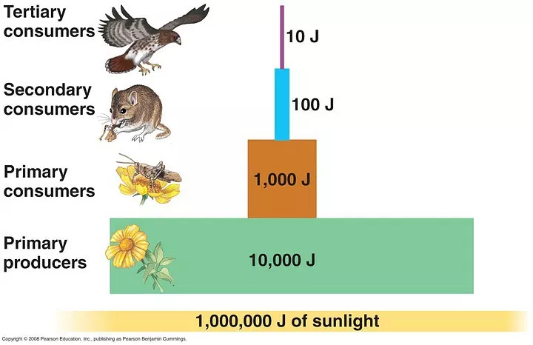

Ex. grass

**Primary (1°) Consumers**

* Feed directly on producers

Ex: rabbit

**Secondary (2°) Consumers**

* Feed directly on primary consumers.

Ex: fox

**Tertiary (3°) Consumers**

* Feed directly on secondary consumers

Ex. coyote

**Bioaccumulation**: When matter is consumed more quickly than it is eliminated it will   
 accumulate or “build up” in an organism

**Biomagnification:** The increase in concentration of a toxin as it moves up a food chain

Ex. A population of mice consume a toxin, since the eagle will eat many mice, the   
 concentration of the toxin will be higher in the eagle

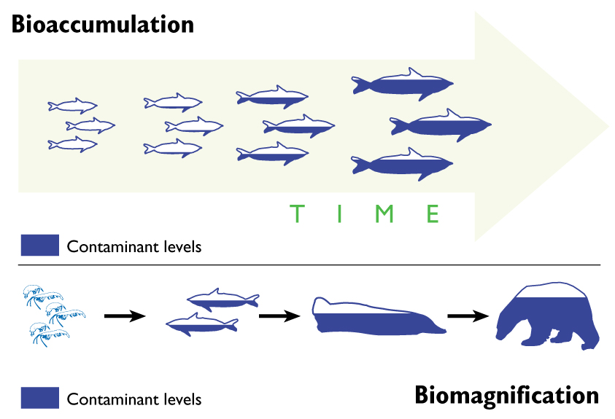

*Portfolio 3*

1. Explain the difference between bioaccumulation & biomagnification

2. Find 2 examples of toxins that biomagnify and explain how they can impact an ecosystem

3. How might toxins introduced to an aquatic system affect terrestrial (land based) organisms?

**Biodiversity & Sustainability**

**Biodiversity:** The variety of life in a region

* High biodiversity = many different individuals, species and/or habitat types
* Biodiversity is related to ecosystem sustainability

Lawn A has 6 caterpillars + 12 snails

Lawn B has 2 caterpillars, 2 snails, 1 butterfly and 1 dragonfly

Which has the higher biodiversity?

How does biodiversity influence sustainability?

**Resilience:** the ability to remain functional and stable in the presence of disturbances or stress

* Increased biodiversity results in increased resilience
* biodiversity can help support food webs, slow the spread of disease, etc. so that ecosystems are better prepared to cope with stress

**Short term stress**

* ecosystem can more easily recover from and adjust to.
* changes may kill some individuals but as long as some survive they can repopulate
  + seasonal peaks in temperature
  + Extreme weather events (floods, hurricanes)

**Long term change**

* ecosystem cannot easily recover from or adjust to
* Conditions may change so that they are outside of the organism's niche and it can no longer inhabit the area
* If species are genetically diverse they may be able to adapt to long term change
  + Climate change
  + Permanent human influence
  + Infestation by invasive species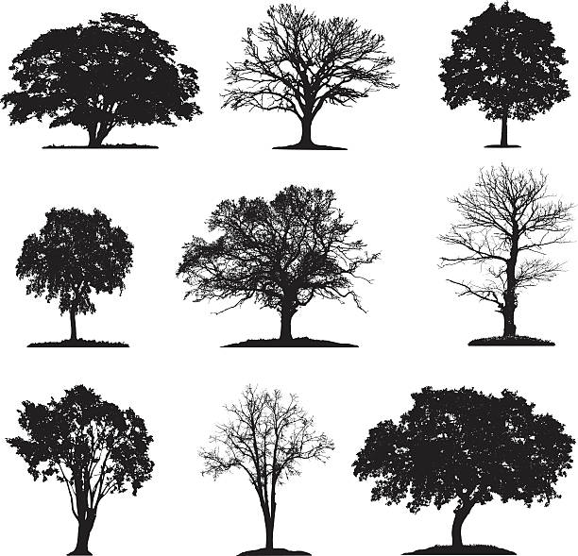

**Activity: Biodiversity & Disease**

1. When the whole class was a monoculture, how many trees survived?

2. In the diverse ecosystem how many trees survived?

3 . Explain these results

**Paradigm:** a view or way of thinking about the world

**Paradigm Shift:** A significant change in the way humans view the world.

Ex. the geocentric vs heliocentric model of our solar system

* A paradigm shift takes many years since people are often resistant to changing the way they think
* Usually controversial when first presented

**Sustainability Paradigm shift**

We’re currently in the middle of a paradigm shift that involves the way people view our planet and the use of its resources.

* People are better understanding the value of ecosystems, biodiversity & the services they provide

*Portfolio 4 p. 337-340*

1.What are 2 pieces of evidence that a paradigm shift is happening currently?

2. How do you think the public seeing the first image of earth (fig. 8.13 p. 336) contributed to this paradigm shift ?

3. What actions are being taken or changes being made as a result of this paradigm shift?

**Ecology Final Unit Assignment**

**Purpose**: Investigate & analyze the impacts of external factors on the sustainability of local   
 ecosystems

**Instructions:**

* Choose a local ecosystem & identify an issue that is impacting that ecosystem
  + Ex. climate change, human activities, invasive species etc.
* Research the topic
  + You will submit a description of the resources you used with your project
* Purpose a course of action to address the issue
* Display or present your findings in a medium of your choice
  + Ex. Video, powerpoint, poster, presentation, game etc.
* Complete the section below & submit with your final project, consider the questions in this section as you work through the project

**Group Members:**

**Ecosystem chosen:**

**Issue facing this ecosystem:**

* What resources did you use to research this topic? (give at least 3)
* Where did the funding for the research you viewed come from?   
  (Government, universities, corporations, non-profit organizations)
* Why might it be important to consider how a research project was funded?
* Were there any technologies used in your proposed course of action? If so what might be some of the risks & benefits of those technologies?