**Science 1206**

**Unit 3: Physics**

**Part A: Uniform Motion**

**Portfolio**

**2019**

Name: __________________

**Science 1206: Physics Portfolio Worksheet #1**

**Vectors and Scalars**

1. Classify each measurement as being either scalar or vector.

(a) 43.5m [W] (b) 1.54min

(c) 87km/h (d) 43.5m

(e) 78km/h [N] (f) 12.6s

(g) 3.4km [E] (h) 2.2x103 km[S]

2. Does a car's speedometer indicate a scalar quantity, a vector quantity, or both? Explain

3. Can the displacement of an object from its original position ever exceed the total distance moved? Explain.

4. A jogger runs 725m [N], then encounters a mad dog. He then turns around and runs back 812m[S]. (a) What is the distance travelled? (b) What is the runner's displacement?

5. 5. A ball rolls 15m to the right, then hits a wall and rolls 8m to the left. What is the (a) distance travelled by the ball? (b) ball's displacement?

6. A frog hops 12m [W], then 14m [E], then another 6m [E]. What is the: (a) frog's distance travelled? (b) frog's displacement?

7. A ball makes two moves. First, the ball rolls 66m [E]. Its final displacement is 14m [W]. (a) What was the ball's second move? (b) What is the ball's total distance travelled?

**Science 1206: Physics Portfolio Worksheet #2: Significant Digits**

1. Identify how many significant digit are in each of the following:

a) 6903 _____________ b) 0.00231 ____________

c) 1200 _____________ d) 1.02 ____________

e) 1.2 _________ f) 0.0002000 ___________

g) 1.23 x 102 __________ h) 5.6 x 10-4 ___________

i) 3 x 10-9 ____________ j) 1720 ____________

k) 0.10 __________ l) 0.000005 ______________

m) 1.235 x 104 _____________ n) 350 ______________

o) 4.2 x 10-12 _______________ p) 9.87 x 106 __________

q) 12037 ____________ r) 10100 _____________

s) 0.0012003 ____________ t) 1.75000 ______________

2. Round each of the following to 2 significant digits.

a) 8040 _________________ b) 0.0300 _________________

c) 699.5 ________________ d) 2.09 ___________________

e) 0.90100 _______________ e) 90100 __________________

f) 475000 __________________ f) 108000 _________________

g) 0.576 _________________ h) 0.00410 ________________

3. Calculate the percent discrepancy in each of the following:

a) A student measures the mass and volume of a piece of copper so they can find out its density. According to the results, the copper has a density of 8.63 g/cm3. If the accepted value for the density is 8.92 g/cm3, what is the student’s percent discrepancy?

b) A student measured the volume of water to be 320.0 ml. If the acceptable volume is 328.0 ml, what is the discrepancy?

c) A piece of string is measured at 32.0 cm long. If the string is supposed to be 30.0 cm long, what is the discrepancy?

4. Solve the following using the correct number of significant figures:

a) 95.62 – 1.558 = __________________ b) 68.67 + 46.4411 = ______________

c) 95.7 – 8.524 = ________________________ d) 61.557 + 2.54 + 8.5 = ____________

e) 8.9 + 7.23 + 76.3722 = _________________ e) 76.3 – 3.3234 = _________________

f) 12.1718 + 77.95 + 39.363 = ______________ g) 6.922 + 24.233 = ________________

5. Solve the following using the correct number of significant figures:

|  |  |  |  |
| --- | --- | --- | --- |
| a) | _________________ | b) | ______________________ |
| c) | __________________ | d) | _____________________ |
| e) | ________________ | f) | ________________ |
| g) | _____________ | g) | __________________ |

6. Solve the following using the correct number of significant figures:

|  |  |  |  |
| --- | --- | --- | --- |
| a) | ______________ | b) | ________________ |
| c) | _____________ | d) | _______________ |

**Science 1206: Physics Portfolio Worksheet # 3**

**Scientific Notation**

1. Write each number in standard format:

a) 9.747 x 104 ___________________________ b) 4.7844 x 10-3 ________________________

c) 1.3 x 102 ___________________________ d) 6.849 x 106 ___________________________

e) 2.34 x 10-4 ___________________________ f) 1.8 x 106 ___________________________

g) 4.72398 x 10-2 _________________________ h) 2.689 x 104 ___________________________

i) 3.37 x 10-7 ___________________________ j) 7 x 10-11 ___________________________

k) 2 x 103 ___________________________ l) 3.7658 x 10-5 ___________________________

2. Write each number in scientific notation:

a) 26635 ____________________________ b) 0.00356 ______________________________

c) 12.87 ____________________________ d) 0.001000 _____________________________

e) 0.02856 ___________________________ f) 199.675 ______________________________

g) 201000 ___________________________ h) 0.000372 _____________________________

i) 12.56865 _______________________ j) 0.000120007 __________________________

k) 1234.675 _______________________ l) 1895577 _____________________________

**Science 1206: Physics Portfolio Worksheet #4**

**Conversions**

**NOTE: 1 m/s = 3.6 km/h**

Convert the following:

|  |  |  |  |
| --- | --- | --- | --- |
| a) | 1200.0 m = ______________km | b) | 232.0 cm = _____________m |
| c) | 35.0 cm = ______________ mm | d) | 545.0 mm = ___________ cm |
| e) | 2.0 m = _____________ mm | f) | 32.0 cm = _____________ m |
| g) | 400.0 minutes = _____________ hours | h) | 5.0 hours = ______________ seconds |
| i) | 4.0 hours = _____________ minutes | j) | 300.0 seconds = ________________ minutes |
| k) | 2005.0 m = __________ km | l) | 3.2 km = ___________________ cm |
| m) | 1256.0 cm = ____________ km | n) | 6.5 m = _____________ mm |
| o) | 3.0 m/s = ___________ km/h | p) | 40.0 km/h = ___________ m/s |
| q) | 100.0 km/h = ____________ m/s | r) | 12.0 m/s = ______________ km/h |
| s) | 2500.0 mm = _______________ m | t) | 4.0 days = ____________ minutes |
| u) | 0.855 kg = _______________ g | v) | 1952 g = _______________ kg |
| w) | 243 mL = ______________L | x) | 1.26 L = ________________ mL |
| y) | 45 500 mg = ______________ kg | z) | 0.00123 kg = _______________ mg |

**Science 1206: Physics Portfolio Worksheet #5**

Uniform Motion Graphing:

**GRAPH A:**

**GRAPH B:**

1. **How far did the object travel in Graph A in 10 s?**
2. **How far did the object travel in Graph B in 4s?**
3. **In graph A and C what was the objects initial Position?**
4. **What is the total displacement in graph A, and Graph B?**
5. **What is happening at 4s in Graph b?**
6. **How far did the object travel on graph B from 4s-8s?**

**Science 1206: Physics Portfolio Worksheet #6**

**Average Speed/ Average Velocity**

1. If Steve throws the football 54.0 meters in 3 .0 seconds, what is the average speed of the football?

2. If it takes Ashley 3.4 seconds to run from the batter’s box to first base at an average speed of 6.5 meters per second, what is the distance she covers in that time?

3. Bart ran 5420.0 meters from the cops and an average speed of 6.00 meters/second before he got caught. How long did he run? (In minutes)

4. If Justin races his Chevy S-10 down Highway 37 for 2560.0 meters in 60.0 seconds, what is his average speed?

5. Chris walks 12.0 meters west in 5.0 seconds and then turns around and walks 22.0 meters east in 10.0 seconds.

a) What is the total distance that Chris has walked?

b) What is Chris’s average speed?

c) What is the total displacement?

d) What is Chris’s average velocity?

6. Courtney walks at a rate of 3.6 m/s [N] for 23.0 seconds and then turns and walks at a rate of 6.1 m/s [E] for 45.0 seconds.

a) What distance did Courtney walk?

b) What is Courtney’s final displacement?

c) What is Courtney’s average speed?

d) What is Courtney’s average velocity?

7. How long would it take a cod fish swimming at 12.0 m/s [E] to travel 508 m [E]?

**Science 1206: Physics Portfolio**

**Worksheet #7 Uniform Motion**



1. Use the graph below to answer the following questions.

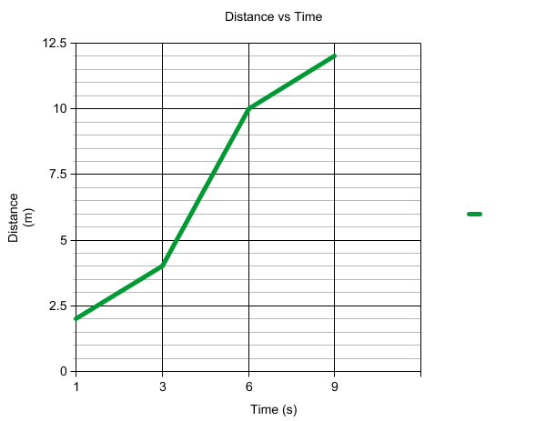

a) How far does the object move in the first 3.0 seconds?

b) What is the average speed of the object during the first 3.0 seconds?

c) How far does the object travel between 3.0 and 6.0 seconds?

d) What is the average speed of the object between 3.0 and 6.0 seconds?

e) How far does the object travel between 6.0 and 9.0 seconds?

f) What is the average speed of the object between 6.0 and 9.0 seconds?

2. Bart Simpson travels to Springfield Elementary School every day on his skateboard. The graph below shows the distance and time Bart travels.

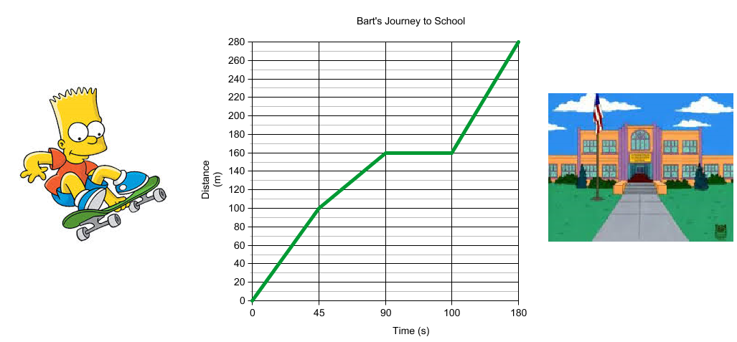

a) How far does Bart travel in the first 45.0 seconds?

b) What is Bart’s average speed during the first 3.0 seconds?

c) How far does Bart travel between 45.0 and 90.0 seconds?

d) What is Bart’s average speed between 45.0 and 90.0 seconds?

e) How far does Bart travel between 90.0 and 100.0 seconds?

f) What is Bart’s average speed between 90.0 and 100.0 seconds?

g) How far does Bart travel between 100.0 and 180.0 seconds?

h) What is Bart’s average speed between 100.0 and 180.0 seconds?

3. Peter Griffin uses a pedometer to calculate the distance he travels. The results are represented in the table below.

|  |  |
| --- | --- |
| **Time (Seconds)** | **Distance (Meters)** |
| **0.0** | **0.0** |
| **20.0** | **150.0** |
| **150.0** | **200.0** |
| **210.0** | **232.0** |
| **240.0** | **300.0** |
| **325.0** | **425.0** |
| **400.0** | **600.0** |

a) Plot the points on the grid below:



b) Draw a line of best fit and use it to determine:

i) Peters average speed between 0.0 and 100.0 seconds.

ii) Peters average speed over the entire time.

4. Describe the journey of the graph below. Include the distance, speed and velocity of each interval. Also determine the total distance, average speed, final displacement and average velocity of the object.

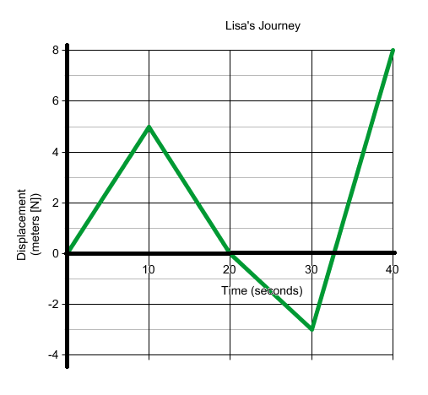

**5. Graph the Position Time Graph:**

A remote control car travels 4.0m [N] in 3.0 seconds before stopping for 2.0 seconds. It then moves 5.0m [S] in 2.0 seconds, stops for 1.0 second, and then proceeds north for 3.0m in 2.0s.

|  |  |  |  |  |  |  |  |  |  |
| --- | --- | --- | --- | --- | --- | --- | --- | --- | --- |
|  |  |  |  |  |  |  |  |  |  |
|  |  |  |  |  |  |  |  |  |  |
|  |  |  |  |  |  |  |  |  |  |
|  |  |  |  |  |  |  |  |  |  |
|  |  |  |  |  |  |  |  |  |  |
|  |  |  |  |  |  |  |  |  |  |
|  |  |  |  |  |  |  |  |  |  |
|  |  |  |  |  |  |  |  |  |  |
|  |  |  |  |  |  |  |  |  |  |
|  |  |  |  |  |  |  |  |  |  |